Public Quarterly Report

Date of Report: 2nd Quarterly Report – July 1, 2025
Contract Number: 693JK32410014POTA
Prepared for: DOT / PHMSA
Project Title: Use of Gamification and Generative AI to provide more effective training for hazardous condition and emergency response.
Prepared by: EnerSys Corporation
Contact Information: Russel W. Treat
E: rtreat@enersyscorp.com
O: 281-598-7110
M: 281-804-6171
For quarterly period ending: June 30, 2025

1: Items Completed During this Quarterly Period:
Item # | Task # | Activity/Deliverable | Title | Federal Cost | Cost Share
3 | 3 | Research, summarize and document current practice for performing emergency and hazardous condition response. | Summary of current industry practice for conducting Emergency Response, Team Training, and Exercises. | 5,360.00 | 20,000.00
5 | 3 | Research, summarize and document current practice for performing Team Training for Liquid Pipeline Hazardous Condition Response | Summary of current industry practice for conducting Emergency Response, Team Training, and Exercises. | 5,360.00 | 20,000.00
6 | 3 | Research, summarize and document current practice for performing Emergency Response Exercises. | Summary of current industry practice for conducting Emergency Response, Team Training, and Exercises. | 5,360.00 | 20,000.00
13 | 8 | Acquire, configure and utilize Generative AI software and ThreatGen Instance | Develop Generative AI Model and Multi-Player training scenarios. | 0.00 | 25,000.00
15 | 8 | Using ThreatGen AutoTableTop framework, evaluate feature set and specify new features required to support multi-player "game" for pipeline scenarios. | Develop Generative AI Model and Multi-Player training scenarios. | 1,344.00 | 8,280.00
19 | 13 | 3rd Quarterly Status Report | Submit 3rd Quarterly Report | 5,952.00 | 2,280.00

2: Items Not-Completed During this Quarterly Period:

Item # | Task # | Activity/Deliverable | Title | Federal Cost | Cost Share
7 | 4 | Define generative AI training criteria for Team Training and Exercise scenarios. | Specification of Training Scenarios, AI training materials, Training Outcomes and Multi-Player Requirements. | 3,776.00 | 6,840.00
8 | 5 | Define materials for use in training generative AI model. | Specification of Training Scenarios, AI training materials, Training Outcomes and Multi-Player Requirements. | 3,224.00 | 8,280.00
9 | 6 | Define scenario training outcomes for use in training the generative AI model. | Specification of Training Scenarios, AI training materials, Training Outcomes and Multi-Player Requirements. | 11,256.00 | 9,120.00
12 | 8 | Specify and create generative AI model training data. | Develop Generative AI Model and Multi-Player training scenarios. | 9,732.00 | 5,700.00
14 | 8 | Train generative AI model to support exercise scenarios. | Develop Generative AI Model and Multi-Player training scenarios. | 1,888.00 | 0.00
16 | 8 | Enhance ThreatGen AutoTableTop framework to incorporate features necessary for running trial scenarios. | Develop Generative AI Model and Multi-Player training scenarios. | 44,460.00 | 0.00
17 | 8 | Define and develop specific scenarios | Develop Generative AI Model and Multi-Player training scenarios. | 6,488.00 | 10,000.00
18 | 8 | Test and refine application | Develop Generative AI Model and Multi-Player training scenarios. | 9,088.00 | 40,000.00

3: Project Financial Tracking During this Quarterly Period:

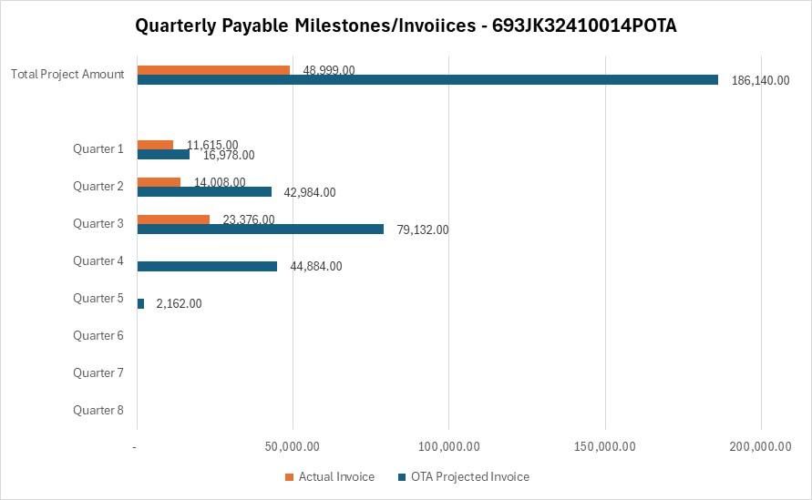

4: Project Technical Status

Item # | Task # | Activity/Deliverable | Title
3 | 3 | Research, summarize and document current practice for performing Team Training. | Summary of current industry practice for conducting Emergency Response, Team Training, and Exercises.
The initiation of the research tasks has been deferred until a relationship was formalized with the Mary K O’Connor Process Safety Center. Agreements were completed on April 17, and the research effort was initiated. The method of performing industry surveys is elaborated in the current sate Research Report which was published June 30, 2025.

A TAP meeting was conducted on May 21. At that time, the TAP members were be engaged in the current state research effort.
5 | 3 | Research, summarize and document current practice for performing emergency and hazardous condition response. | Define generative AI training criteria for Team Training scenario for Liquid Pipeline Hazardous Condition Response.
See answer to Item 3, Task 3 above.
6 | 3 | Research, summarize and document current practice for performing Emergency Response Exercises. | Summary of current industry practice for conducting Emergency Response, Team Training, and Exercises.
See answer to Item 3, Task 3 above.
13 | 8 | Acquire, configure and utilize Generative AI software and ThreatGen Instance | Develop Generative AI Model and Multi-Player training scenarios.
A Pipeliners TableTop powered by ThreatGen was stood up and access was provided to the TAP.
15 | 8 | Using ThreatGen AutoTableTop framework, evaluate feature set and specify new features required to support multi-player "game" for pipeline scenarios. | Develop Generative AI Model and Multi-Player training scenarios.
The project team has meet and run initial scenarios to evaluate the features and interface of the initial release of ThreatGen multi-player application. This feedback was provided to the development team.
19 | 13 | 3rd Quarterly Status Report | Submit 3rd Quarterly Report
Prepared and distributed the 3rd Quarterly Report.

5: Project Schedule

Item # | Task # | Activity/Deliverable | Title
7 | 4 | Define generative AI training criteria for Team Training and Exercise scenarios. | Specification of Training Scenarios, AI training materials, Training Outcomes and Multi-Player.
This delay in engaging the Mary K O’Connor Process Safety Center resulted in a delay in completing the current state Research Report. With the completion of the current state Research Report, this task can be initiated. It is anticipated that this task will be completed by end of August 2025.
8 | 5 | Define materials for use in training generative AI model | Specification of Training Scenarios, AI training materials, Training Outcomes and Multi-Player.
Upon completion of Item 7, Task 4, AI Training materials can be defined. The expected completion of this task is September 2025.
9 | 6 | Define scenario training outcomes for use in training the generative AI model. | Specification of Training Scenarios, AI training materials, Training Outcomes and Multi-Player Requirements.
Upon completion of Item 7, Task 4, AI Scenario Training materials can be defined. The expected completion of this task is September 2025.

12 | 8 | Specify and create generative AI model training data. | Develop Generative AI Model and Multi-Player training scenarios.
Upon completion of Item 7, Task 4, training material can be created. This will be an iterative process and will be completed following the definition of training materials. Expected completion of this task is September 2025.
14 | 8 | Train generative AI model to support exercise scenarios. | Develop Generative AI Model and Multi-Player training scenarios.
Training of the GenAI model and refinement of scenarios is an iterative process. It will begin as soon as a basic implement is ready. Likely late August. Expected completion of this tasks is October 2025.
16 | 8 | Enhance ThreatGen AutoTableTop framework to incorporate features necessary for running trial scenarios. | Develop Generative AI Model and Multi-Player training scenarios.
See response to Item 14, Task 8 above.
17 | 8 | Define and develop specific scenarios | Develop Generative AI Model and Multi-Player training scenarios.
See response to Item 14, Task 8 above.
18 | 8 | Test and refine application | Develop Generative AI Model and Multi-Player training scenarios.
See response to Item 14, Task 8 above.

